Anthony Ringer

Computer Architecture - Assignment 1: Creating a Simple ALU

Phase 1

Required operands - 9
Arithmetic addition
Increment
Decrement
Comparison (with 3 outputs: one for equals, one for less than and one for greater than)
Logic bitwise Not
Logic bitwise And
Logic bitwise Or
Register right logic shift
Register left logic shift

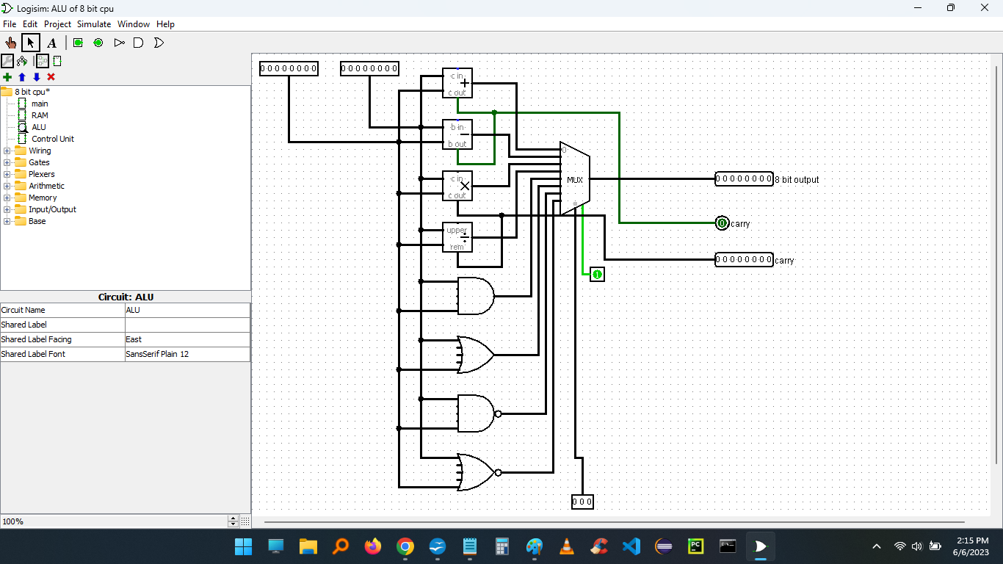

Suggested additional operands - 5
Arithmetic subtraction
Arithmetic multiplication
Arithmetic Division
Logic bitwise NAND
Logic bitwise NOR

My reasoning for suggesting these 5 operands is because when I build the ALU during the lesson, these operands were included in the circuit already and because they are commonly used operands in NASM assembly language.
Phase 2

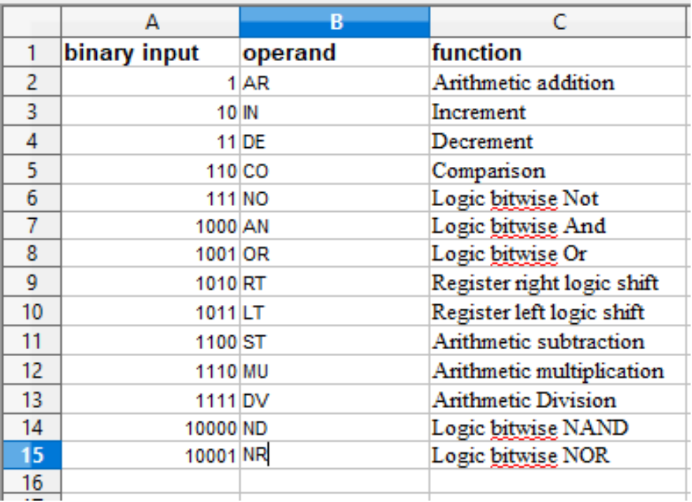
I want my operands to handle one instruction each for simplicity.

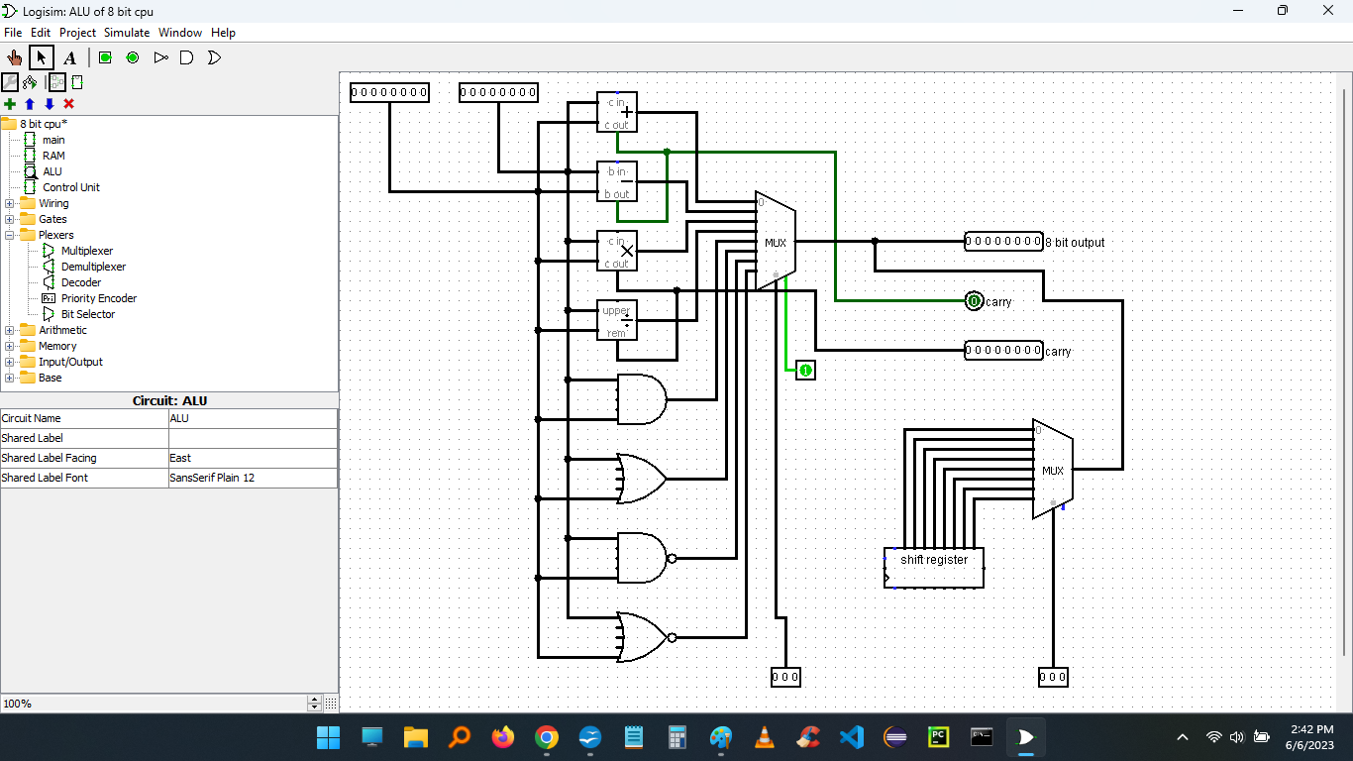

Phase 3

Addition
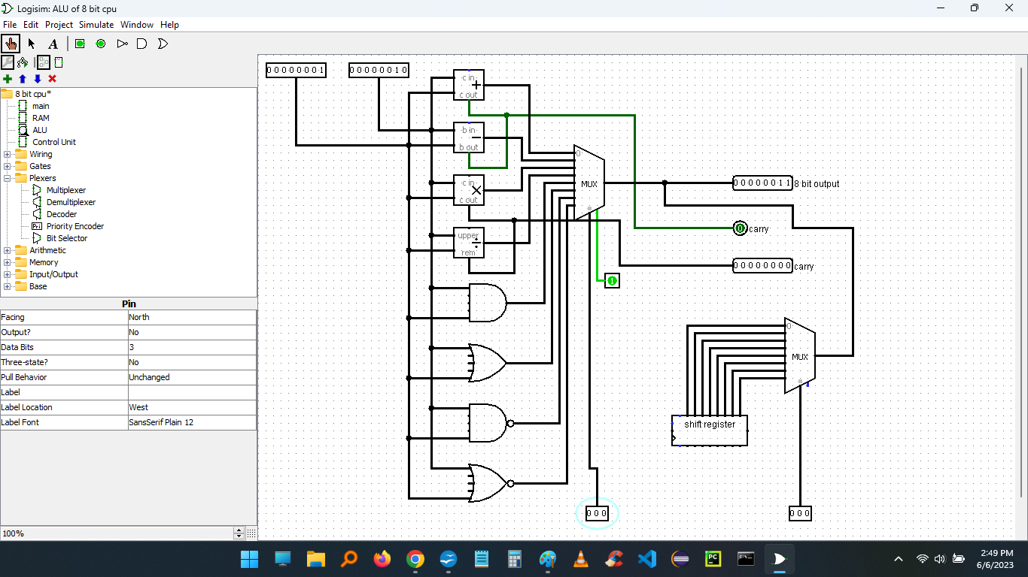
AND
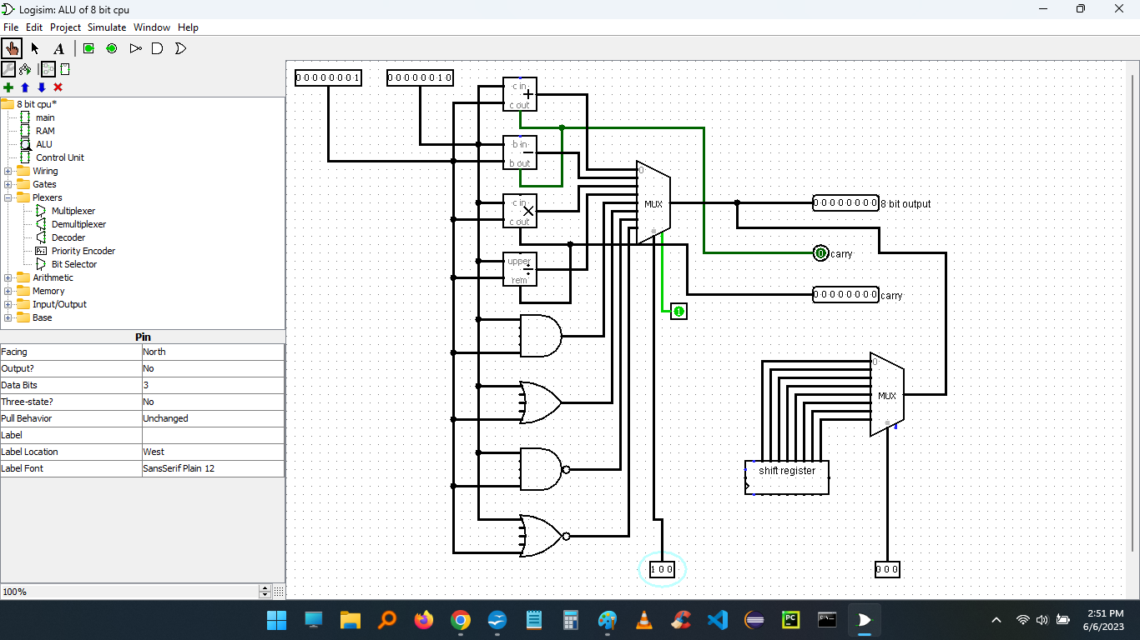

right logic shift
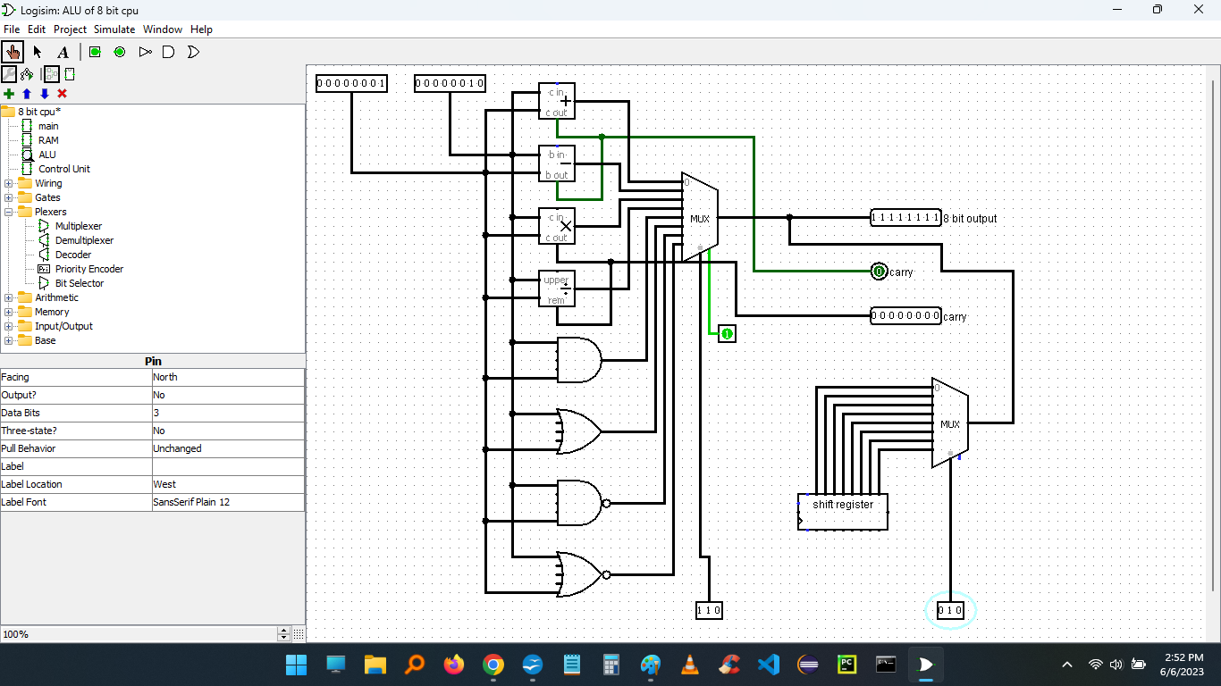

Phase 4

Added JMP and CJMP
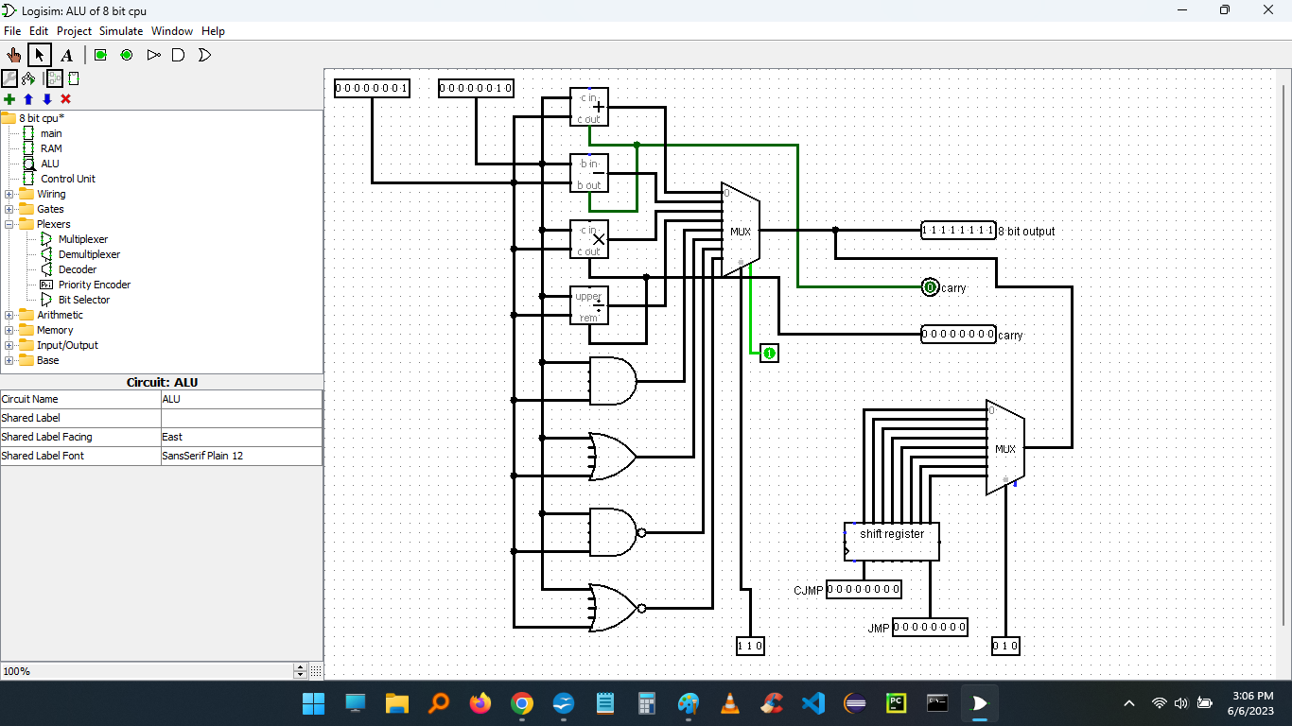

Adds 2 operands
:AR
:RT

Adds 2 operands until new value is 0
:AR
:RT
loop:
:CP = 0

Increments register by 2 ten times

:AR 2
:RT
:AR 2
:RT
:AR 2
:RT
:AR 2
:RT
:AR 2
:RT
:AR 2
:RT
:AR 2
:RT
:AR 2
:RT
:AR 2
:RT
:AR 2
:RT

Shifts register until least significant bit is 0

:DE
:DE
:DE
:DE
:DE
:DE
:DE
:RT 0
:RT 0
:RT 0
:RT 0
:RT 0
:RT 0
:RT 0
:RT 0

Shifts register until 11111111

:DE
:DE
:DE
:DE
:DE
:DE
:RT 1
:RT 1
:RT 1
:RT 1
:RT 1
:RT 1
:RT 1
:RT 1

